# Assignment - 3 Bucket And Watson assistant

|  |  |
| --- | --- |
| Assignment Date | 4 NOVEMBER 2022 |
| Student Name | DEEPA DHARSHINI V |
| Team ID | PNT2022TMID01622 |
| Maximum Marks | 2 Marks |

**Questions:**

# Create a Bucket in IBM object storage.

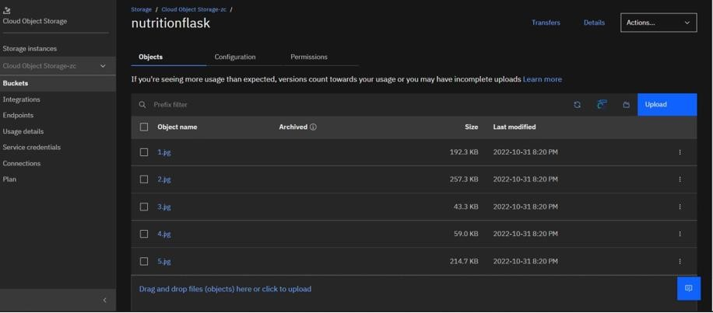

1. **Upload an 5 images to ibm object storage and make it public. write html code to displaying all the 5 images.**

# Index.html

<!DOCTYPE html>

<html lang="en">

<head>

<meta charset="UTF-8">

<meta http-equiv="X-UA-Compatible" content="IE=edge">

<meta name="viewport" content="width=device-width, initial-scale=1.0">

<title>Smart Fashion shop</title>

<link rel="stylesheet" href="https://flask-plasma1.s3.jp-tok.cloud- object-storage.appdomain.cloud/index.css">

<style>

body{

background-color: aqua; display: flex;

align-items: center; justify-content: center; flex-direction: column;

}

img{

height: 240px; border-radius: 10px; margin: 10px;

}

</style>

</head>

<body>

<h1>Welcome to Image Gallery</h1>

<div>

<img src="https://classnutrition.s3.jp-tok.cloud-object- storage.appdomain.cloud/WhatsApp%20Image%202022-10-30%20at%2019.36.38.jpg" alt="dress" srcset="">

<img src="https://classnutrition.s3.jp-tok.cloud-object- storage.appdomain.cloud/WhatsApp%20Image%202022-10-30%20at%2019.36.40.jpg" alt="dress" srcset="">

<img src="https://classnutrition.s3.jp-tok.cloud-object- storage.appdomain.cloud/WhatsApp%20Image%202022-10-30%20at%2019.36.401.jpg" alt="dress" srcset="">

<img src="https://classnutrition.s3.jp-tok.cloud-object- storage.appdomain.cloud/WhatsApp%20Image%202022-10-30%20at%2019.36.402.jpg" alt="dress" srcset="">

<img src="https://classnutrition.s3.jp-tok.cloud-object- storage.appdomain.cloud/WhatsApp%20Image%202022-10-30%20at%2019.36.403.jpg" alt="dress" srcset="">

</div>

<script> window.watsonAssistantChatOptions = {

integrationID: "3a3031a0-6417-4ea1-8d7f-aa027a707ff4", // The ID of this integration.

region: "jp-tok", // The region your integration is hosted in. serviceInstanceID: "83cc55ca-5fdb-4ffd-b11a-cebe2fab5f4d", // The ID of

your service instance.

onLoad: function(instance) { instance.render(); }

};

setTimeout(function(){

const t=document.createElement('script'); t.src="https://web-

chat.global.assistant.watson.appdomain.cloud/versions/" + (window.watsonAssistantChatOptions.clientVersion || 'latest') + "/WatsonAssistantChatEntry.js";

document.head.appendChild(t);

});

</script>

</body>

</html>

# Upload a css page to the object storage and use the same page in your HTML code.

1. <!DOCTYPE html>

<html lang="en">

<head>

<meta charset="UTF-8">

<meta http-equiv="X-UA-Compatible" content="IE=edge">

<meta name="viewport" content="width=device-width, initial-scale=1.0">

<title>Smart Fashion shop</title>

<link rel="stylesheet" href="https://flask-plasma1.s3.jp-tok.cloud- object-storage.appdomain.cloud/index.css">

</head>

<body>

<h1>Welcome to Image Gallery</h1>

<div>

<img src="https://classnutrition.s3.jp-tok.cloud-object- storage.appdomain.cloud/WhatsApp%20Image%202022-10-30%20at%2019.36.38.jpg" alt="dress" srcset="">

<img src="https://classnutrition.s3.jp-tok.cloud-object- storage.appdomain.cloud/WhatsApp%20Image%202022-10-30%20at%2019.36.40.jpg" alt="dress" srcset="">

<img src="https://classnutrition.s3.jp-tok.cloud-object- storage.appdomain.cloud/WhatsApp%20Image%202022-10- 30%20at%2019.36.401.jpg" alt="dress" srcset="">

<img src="https://classnutrition.s3.jp-tok.cloud-object- storage.appdomain.cloud/WhatsApp%20Image%202022-10- 30%20at%2019.36.402.jpg" alt="dress" srcset="">

<img src="https://classnutrition.s3.jp-tok.cloud-object- storage.appdomain.cloud/WhatsApp%20Image%202022-10- 30%20at%2019.36.403.jpg" alt="dress" srcset="">

</div>

</body>

</html>

# Output:

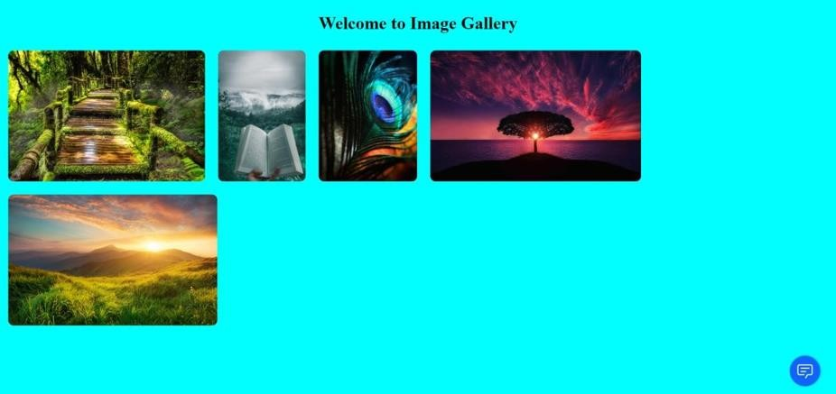

**4.Design a chatbot using IBM Watson assistant for hospital. Ex: User comes with query to know the branches for that hospital in your city. Submit the web URL of that chat bot as a assignment.**

# Url :- [chatbot link](https://web-chat.global.assistant.watson.appdomain.cloud/preview.html?backgroundImageURL=https%3A%2F%2Feu-gb.assistant.watson.cloud.ibm.com%2Fpublic%2Fimages%2Fupx-2187bdc6-3463-4336-a0e5-105ac4d979db%3A%3A31897cd3-e620-4527-80d8-c93d7c618899&integrationID=fd3649a9-27f7-43a9-96c0-5ca4d5bbf885&region=eu-gb&serviceInstanceID=2187bdc6-3463-4336-a0e5-105ac4d979db) <- click Image

**5 .Create Watson assistant service with 10 steps and use 3 conditions in it. Load that script in HTML page**

